

Cyber Security

CS_TALAKUNCHI NETWORKS BATCH 2



Name :- Ojus P. Jaiswal

**Project 1**

**Information Gathering and Exploitation (Authentication Bypass)**

**Task 1 :-** Take some random websites using Google hacking database and enter into their admin panel using SQL Injections (Manual and using a tool called burp suite)

**Solution :-**

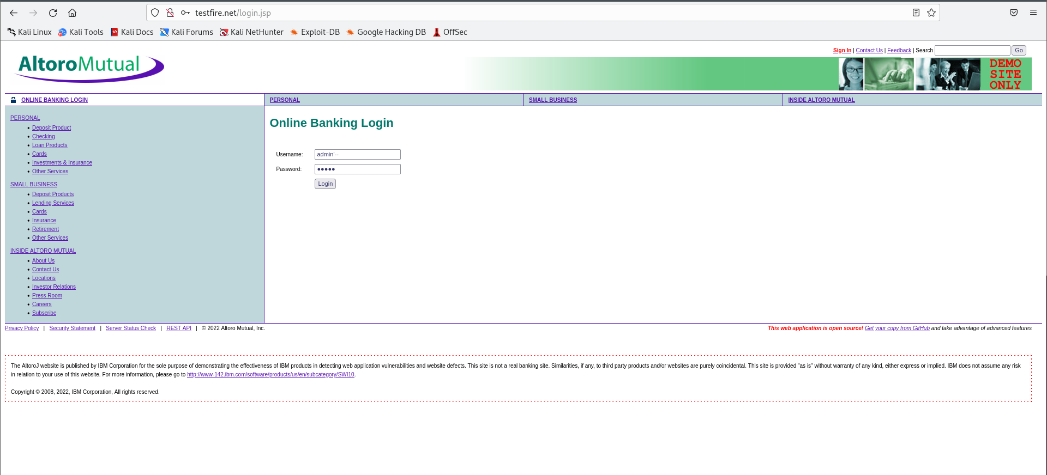

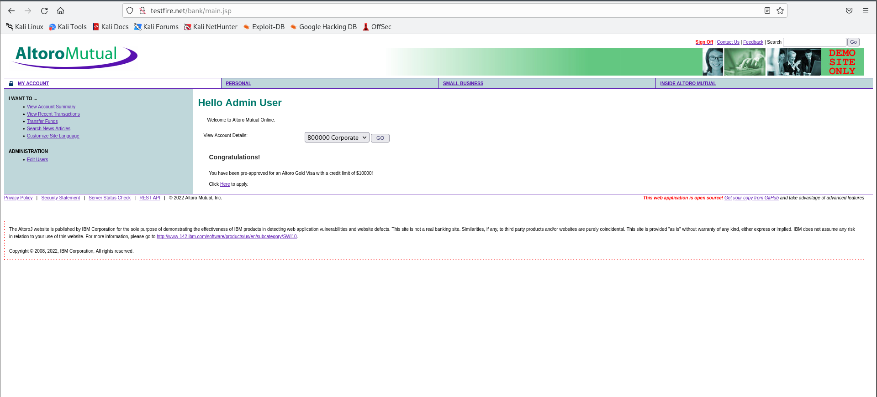

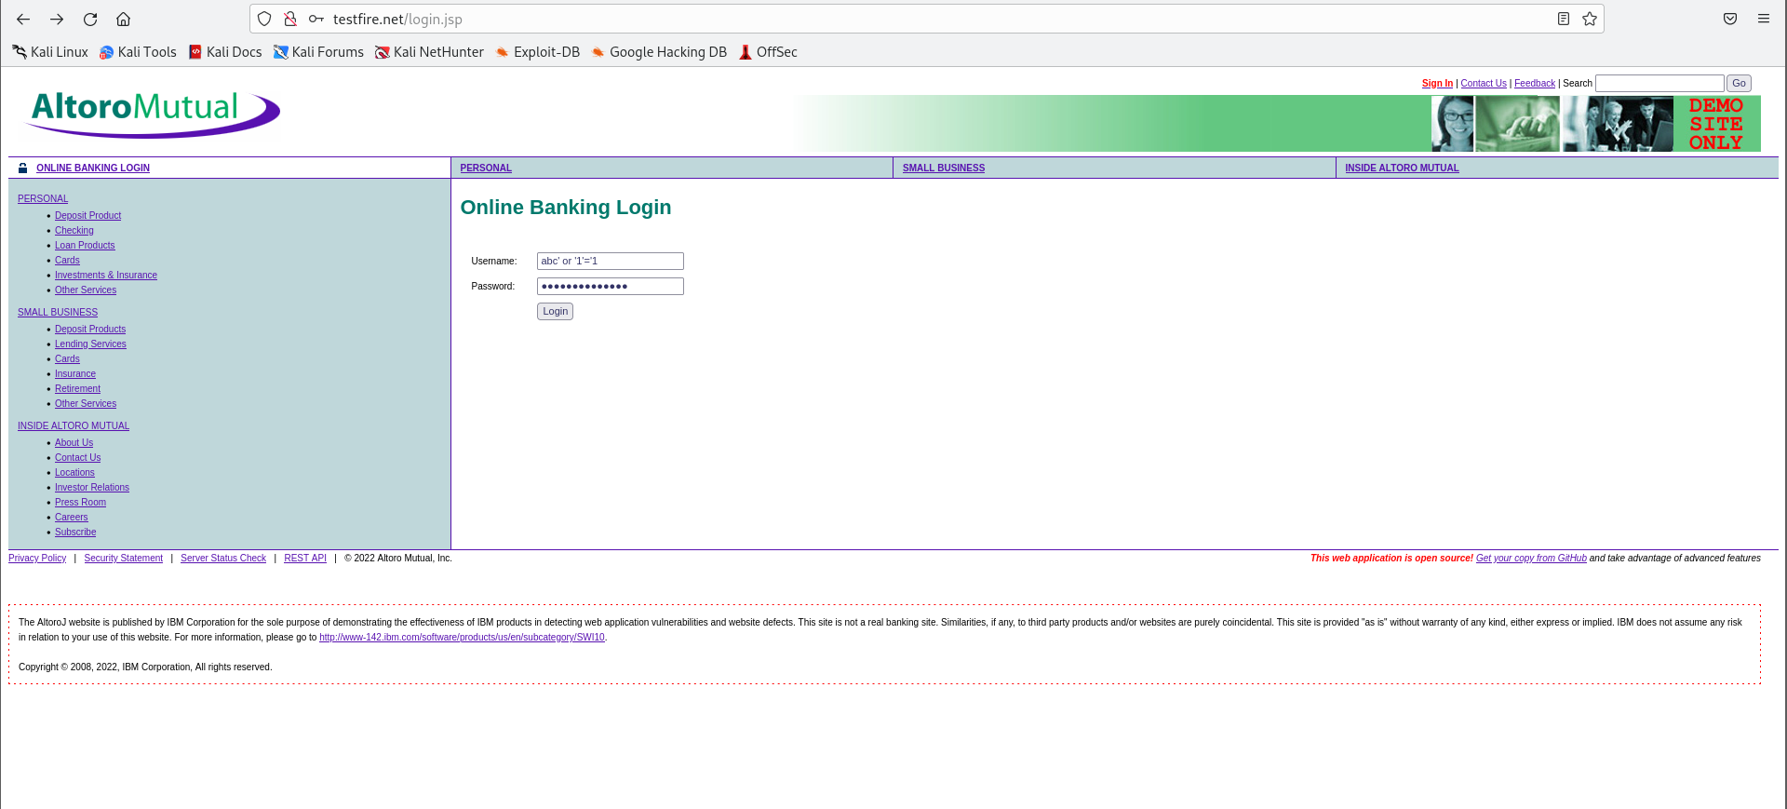

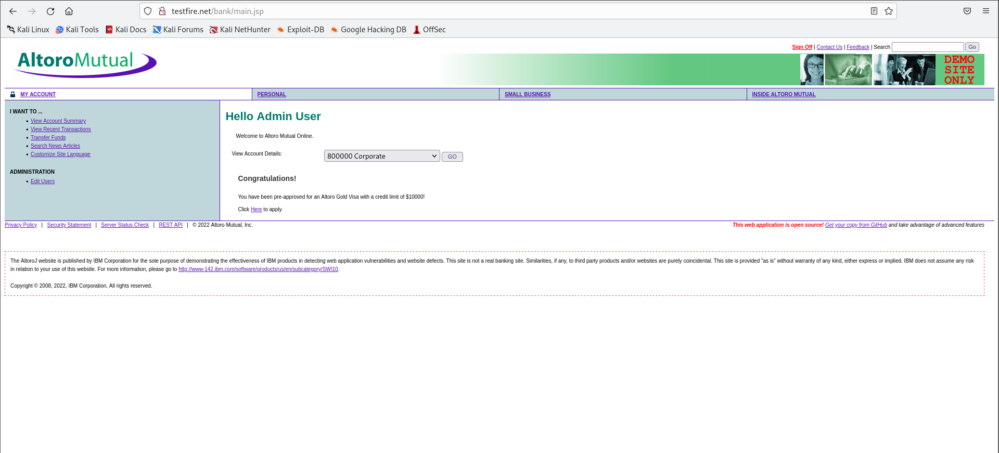

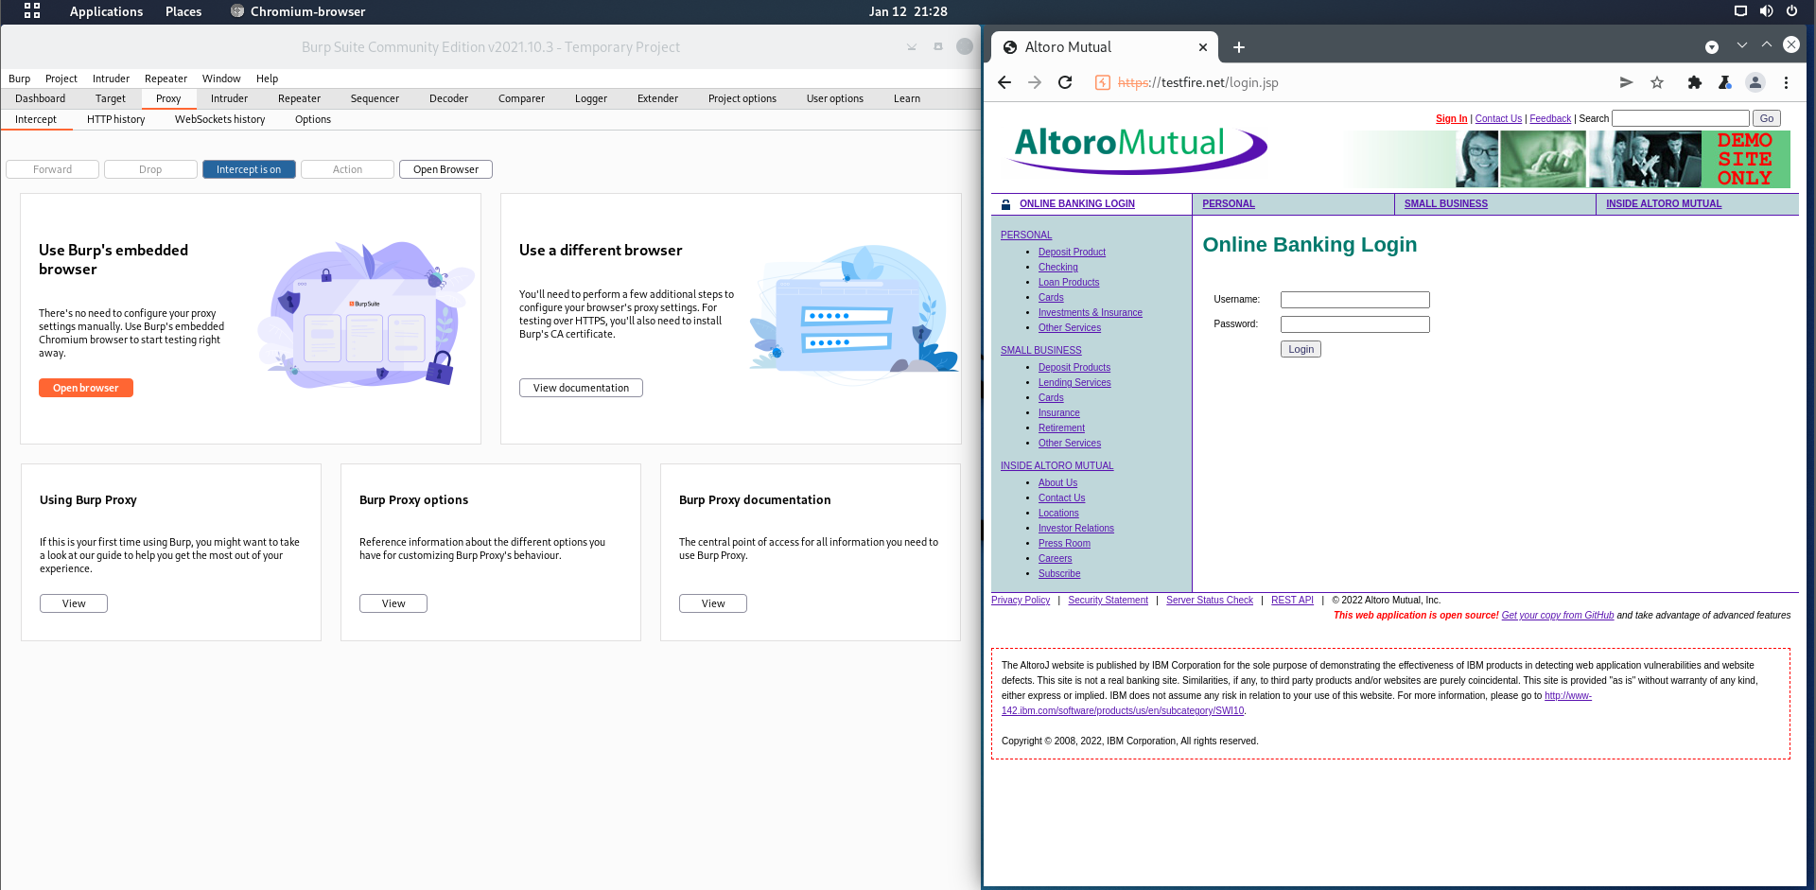

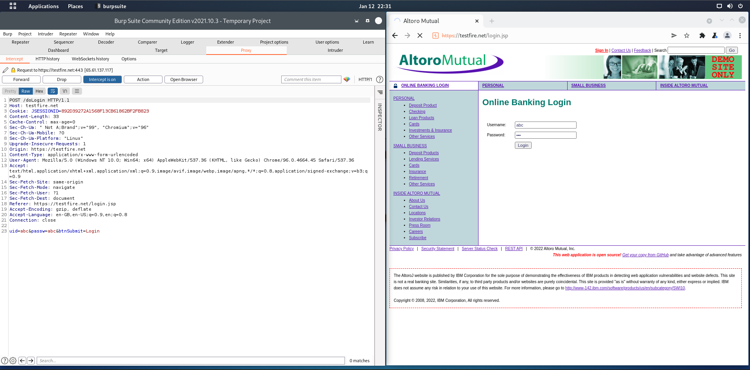

**Task 2 :-**Show some live cameras using Google hacking database.

**Solution :-**

